*Version 2019-Spring-1.1, Revised 6 February 2019*

Activity 3.1:

Git - Introduction

This activity is to reinforce and review Git basics. You have been using GitLab as a repository manager for turning in your code in previous classes. This activity offers to review the steps that have been followed to do the same and refresh student’s knowledge.

Sharing Your Work Through GitLab

When you use GitLab as a way to share your work with your instructor and your partner(s), you need to interact with the **gitlab.com** server.

## Content Learning Objectives

*After completing this activity, students should be able to:*

* Describe the process of submitting assignments through GitLab.

## Process Skill Goals

*During the activity, students should make progress toward:*

* Leveraging prior knowledge and experience of other students. (Teamwork)

## Team Roles

*Decide what role each of you will play for today. Choose a role that you have not played before, or recently. The goal should be to have all team members rotate through the roles on a regular basis to become comfortable with all the roles. If you have only three people, one should have two roles. If you have five people, two may share the same role. Record role assignments here.*

|  |  |
| --- | --- |
| Manager |  |
| Presenter |  |
| Recorder |  |
| Reflector |  |

# Model 1: Before Starting Lab1

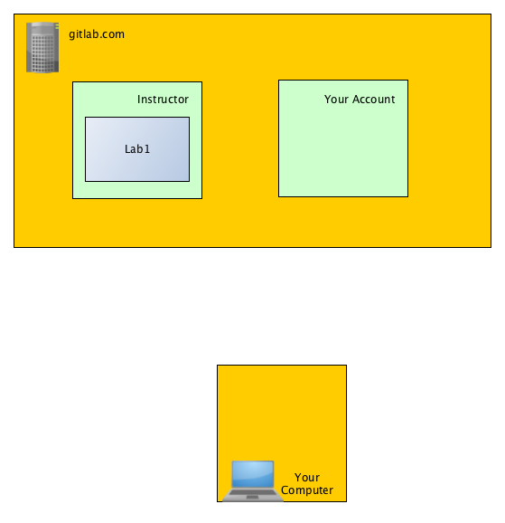

## Questions (2 min)

1. Where does your GitLab account and your instructor’s GitLab account exist?
2. At this point, where is Lab1?

# Model 2

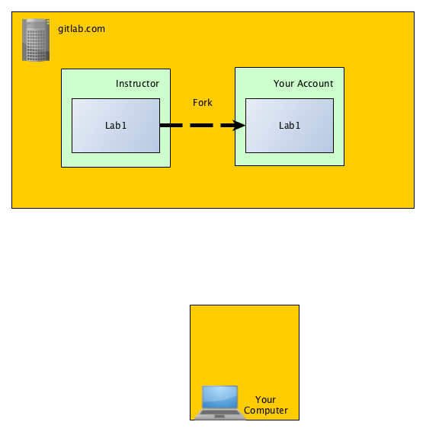

## Questions (2 min)

1. What happens in Model 2?
2. What was the name of the operation?
3. Why would you need/want to do this?

# Model 3

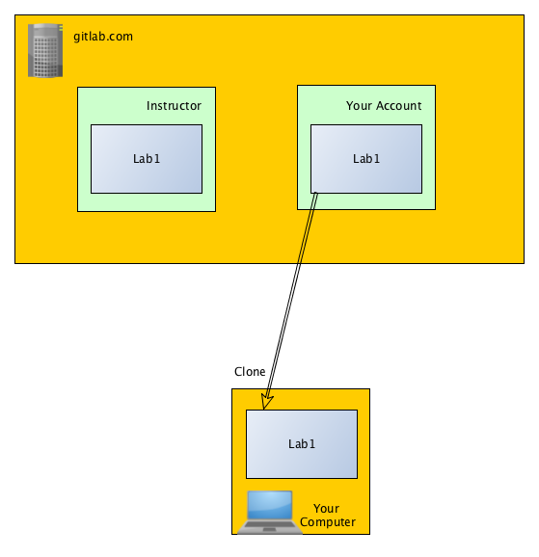

## Questions (3 min)

1. What happens in Model 3?
2. What was the name of the operation?
3. How is this different from what happened in Model 2?
4. Why would you need/want to do this?

# Model 4

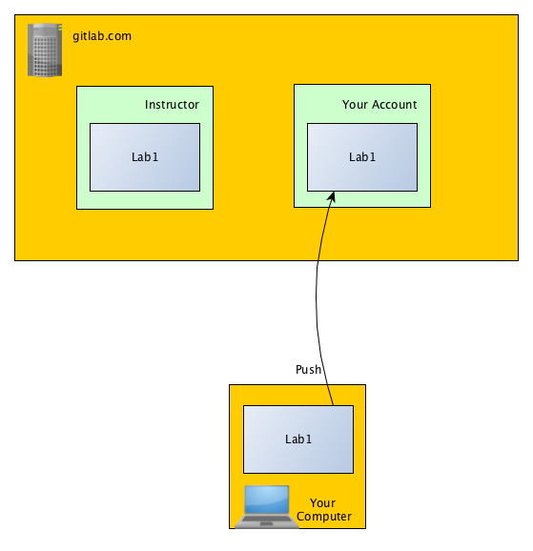

## Questions (2 min)

Between Model 3 and Model 4, you make changes to Lab1 on your computer.

1. What happens in Model 4?
2. What was the name of the operation?
3. Why would you need/want to do this?

# Model 5

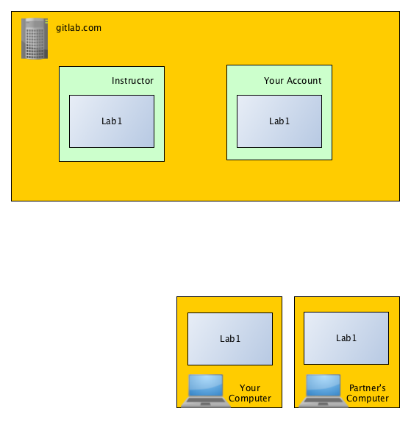

## Questions (3 min)

1. What happened between Model 4 and Model 5?
2. What operation was used?
3. Who issued the operation?
4. Why would you need/want to do this?

# Model 6

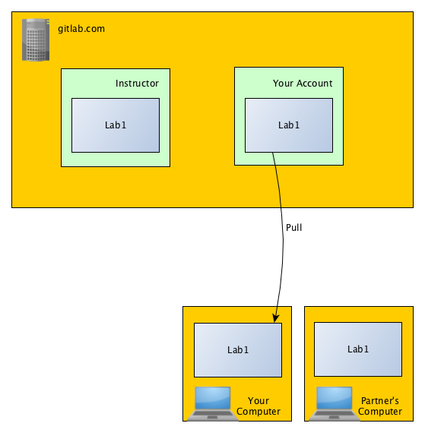

## Questions (4 min)

1. Between Model 5 and Model 6, your partner made changes to Lab1 on their computer, and got those changes into your account. What operation did your partner use?
2. What happens in Model 6?
3. What is the name of the operation?
4. Who issued the operation?
5. Why would you need/want to do this?
6. Do you think anyone with a GitLab account should be able to issue the operations your partner did in Models 5 and 6? Why or why not?
7. What operations would your instructor have to issue to get a copy of your Lab1 to grade it?

Copyright © 2019 Karl R. Wurst. This work is licensed under a Creative Commons Attribution-ShareAlike 4.0 International License.